CAS SciFinder Task History

January 3, 2025, 2:48 PM

Initiating Search

Reactions: | Structure Search  

Filtered By:
Structure Match: As Drawn
Substance Role: Reactant
Yield: 90-100%
Non-Participating Functional Groups: Ether, Alkene, Organometal, Cyclic alkene, Amine, Diene, Cyclopentadienyl metal, Tertiary amine, Carboxamidine, Amide, Imine, Alcohol, Ketone, Primary amine, Urea, Acetal, Acyclic alkene, Acyclic ketone, Carboxylic ester, Halide, Primary alcohol, Secondary amine, Nitrile, Carboxylic acid, Phenyl halide, Sulfide, Aldehyde, Alkyl halide, Alkyne, Cyclic alcohol, Cyclic ketone, Nitro, Secondary alcohol, Unsaturated ester, Phosphonate
Reaction Type: Full
Language: English
Publication Year: 2000 to 2024

Excluded:
Reaction Mapping: No Mapping Data Available
Solvent: THF-d₈, Acetonitrile-d₃, Benzene-d₆
Reaction Notes: Thermal, Microwave Irradiation, Ultrasound
CA Section: Electrochemical, Radiational, and Thermal Energy Technology, Magnetic Phenomena

Search Tasks

1. Exported: Returned Reaction Results + Filters (152) View Results

View in CAS SciFinder

Reactions (50)

1. Scheme 1 (1 Reaction)

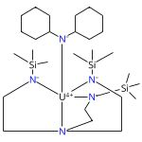 |  | 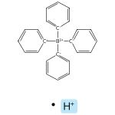  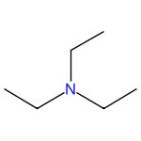 |  | 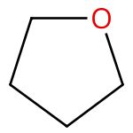
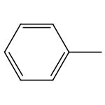 |  | 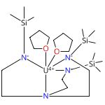  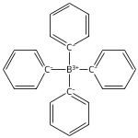

Halide, Amide, Cationic, Manganese Carbonylate, and Oxide Derivatives of Triamidosilylamine Uranium Complexes
By: Gardner, Benedict M.; et al
Inorganic Chemistry (2011), 50(19), 9631-9641.
Find It @ Emory
10.1021/ic201372a
View All Sources in CAS SciFinder

Steps: 1, Yield: 95%
CAS Reaction Number: 31-562-CAS-9224253
1.1 | Solvents: Tetrahydrofuran

2. Scheme 2 (1 Reaction)

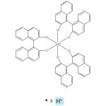  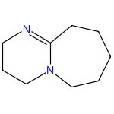 |  |  |  | 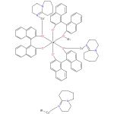

Synthesis of novel copper-rare earth BINOLate frameworks from a hydrogen bonding DBU-H rare earth BINOLate complex
By: Panetti, Grace B.; et al
Dalton Transactions (2018), 47(41), 14408-14410.
Find It @ Emory
10.1039/c8dt03335h
View All Sources in CAS SciFinder

Steps: 1, Yield: 94%
CAS Reaction Number: 31-614-CAS-27704811
1.1 | Reagents: (2,4,6-Trimethylphenyl)copper
 | Solvents: Toluene; 3 h, rt

3. Scheme 3 (3 Reactions)

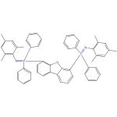 |  | 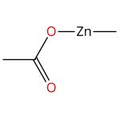 |  | 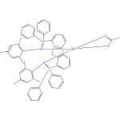

Catalysts for the polymerization of cyclic lactones
Assignee: University of Lethbridge
United States, US20100130753 A1 2010-05-27
Espacenet
View All Sources in CAS SciFinder

Steps: 1, Yield: 99%
CAS Reaction Number: 31-562-CAS-2272833
1.1 | Solvents: Bromobenzene, Toluene; 30 min, rt

Catalysts for the polymerization of cyclic lactones
Assignee: University of Lethbridge
Canada, CA2686355 A1 2010-05-24
Espacenet
View All Sources in CAS SciFinder

Steps: 1, Yield: 99%
CAS Reaction Number: 31-562-CAS-3096197
1.1 | Solvents: Bromobenzene, Toluene; 30 min, rt

Cationic organozinc complexes of a bis(phosphinimine) pincer ligand: synthesis, structural and polymerization studies
By: Wheaton, Craig A.; et al
Dalton Transactions (2010), 39(16), 3861-3869.
Find It @ Emory
10.1039/b922543a
View All Sources in CAS SciFinder

Steps: 1, Yield: 99%
CAS Reaction Number: 31-562-CAS-4181903
1.1 | Solvents: Bromobenzene; 15 min, rt

4. Scheme 4 (1 Reaction)

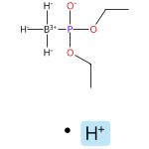 |  | 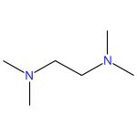 |  | 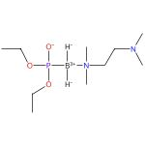

Reaction of Boranephosphonate Diesters with Pyridines or Tertiary Amines in the Presence of Iodine: Synthetic and Mechanistic Studies
By: Golebiewska, Justyna; et al
Journal of Organic Chemistry (2020), 85(6), 4312-4323.
Find It @ Emory
10.1021/acs.joc.9b03506
View All Sources in CAS SciFinder

Steps: 1, Yield: 95%
CAS Reaction Number: 31-614-CAS-26135332
1.1 | Reagents: Iodine
 | Solvents: Dichloromethane; 10 min, rt

5. Scheme 5 (1 Reaction)

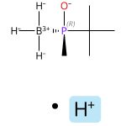  Absolute stereochemistry shown,  Rotation (-) |  | 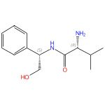  Absolute stereochemistry shown |  | 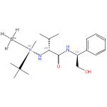  Absolute stereochemistry shown

Highly Enantioselective Iridium-Catalyzed Hydrogenation of Cyclic Enamides
By: Salomo, Ernest; et al
Angewandte Chemie, International Edition (2016), 55(28), 7988-7992.
Find It @ Emory
10.1002/anie.201602219
View All Sources in CAS SciFinder

Steps: 1, Yield: 93%
CAS Reaction Number: 31-614-CAS-26337504
1.1 | Reagents: Triethylamine, Methanesulfonic anhydride
 | Solvents: Dichloromethane; 1 h, -20 °C
1.2 | overnight, -20 °C

6. Scheme 6 (1 Reaction)

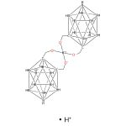 |  | 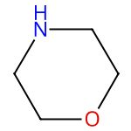 |  | 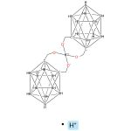

Synthesis and some transformations of di(o-carborano-1,2-dimethyl)borate
By: Kazantsev, A. V.; et al
Russian Journal of General Chemistry (2016), 86(1), 199-201.
Find It @ Emory
10.1134/s1070363216010333
View All Sources in CAS SciFinder

Steps: 1, Yield: 90%
CAS Reaction Number: 31-614-CAS-27070139
1.1 | Solvents: Benzene

7. Scheme 7 (1 Reaction)

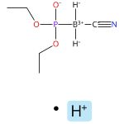 |  | 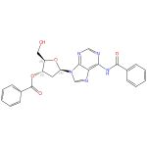  Absolute stereochemistry shown |  | 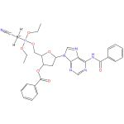

Syntheses of novel substituted-boranophosphate nucleosides
By: Vyakaranam, Kamesh; et al
Nucleosides, Nucleotides & Nucleic Acids (2002), 21(8 & 9), 581-598.
Find It @ Emory
10.1081/ncn-120015070
View All Sources in CAS SciFinder

Steps: 1, Yield: 97%
CAS Reaction Number: 31-614-CAS-27880547
1.1 | Reagents: Dicyclohexylcarbodiimide
 | Solvents: Acetonitrile; 72 h, rt
1.2 | Solvents: Dichloromethane

8. Scheme 8 (1 Reaction)

 |  | 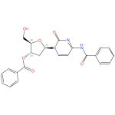  Absolute stereochemistry shown |  | 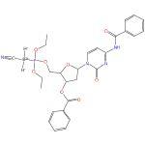

Syntheses of novel substituted-boranophosphate nucleosides
By: Vyakaranam, Kamesh; et al
Nucleosides, Nucleotides & Nucleic Acids (2002), 21(8 & 9), 581-598.
Find It @ Emory
10.1081/ncn-120015070
View All Sources in CAS SciFinder

Steps: 1, Yield: 94%
CAS Reaction Number: 31-614-CAS-25431619
1.1 | Reagents: Dicyclohexylcarbodiimide
 | Solvents: Acetonitrile; 72 h, rt
1.2 | Solvents: Dichloromethane

9. Scheme 9 (1 Reaction)

 |  | 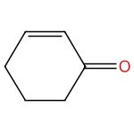 |  | 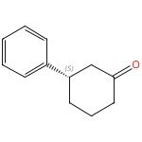  Absolute stereochemistry shown,  Rotation (-)

Indole-olefin-oxazoline (IndOlefOx)-ligands: synthesis and utilization in asymmetric Rh-catalyzed conjugate addition
By: Kuuloja, Noora; et al
Tetrahedron: Asymmetry (2011), 22(4), 468-475.
Find It @ Emory
10.1016/j.tetasy.2011.02.020
View All Sources in CAS SciFinder

Steps: 1, Yield: 98%
CAS Reaction Number: 31-614-CAS-25624303
1.1 | Catalysts: Di-μ-chlorotetrakis(η²-ethene)dirhodium, 2-[(4S)-4,5-Dihydro-4-(phenylmethyl)-2-oxazolyl]-3-[(1E)-2-(3,4-dimethoxyphenyl)ethenyl]-1-methyl-1H-indole
 | Solvents: 1,4-Dioxane; 10 min, rt
1.2 | Reagents: Potassium hydroxide
 | Solvents: Water; 22 h, 80 °C

10. Scheme 10 (2 Reactions)

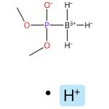 |  | 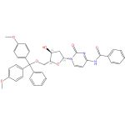  Absolute stereochemistry shown |  | 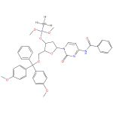

A Novel Method for the Synthesis of Dinucleoside Boranophosphates by a Borano-Phospho-Triester Method
By: Shimizu, Mamoru; et al
Journal of Organic Chemistry (2004), 69(16), 5261-5268.
Find It @ Emory
10.1021/jo0493875
View All Sources in CAS SciFinder

Steps: 1, Yield: 96%
CAS Reaction Number: 31-614-CAS-26064507
1.1 | Reagents: Diisopropylethylamine, 3-Nitro-1,2,4-triazole, Bis(2-oxo-3-oxazolidinyl)phosphinic chloride
 | Solvents: Tetrahydrofuran; 30 min, rt

A new boranophosphorylation reaction for the synthesis of deoxyribonucleoside boranophosphates
By: Wada, Takeshi; et al
Tetrahedron Letters (2002), 43(23), 4137-4140.
Find It @ Emory
10.1016/s0040-4039(02)00780-3
View All Sources in CAS SciFinder

Steps: 1, Yield: 96%
CAS Reaction Number: 31-614-CAS-25517955
1.1 | Reagents: Diisopropylethylamine, Bis(2-oxo-3-oxazolidinyl)phosphinic chloride, MSNT
 | Solvents: Tetrahydrofuran

11. Scheme 11 (1 Reaction)

 |  | 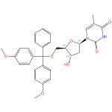  Absolute stereochemistry shown,  Rotation (+) |  | 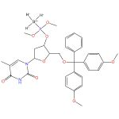

A new boranophosphorylation reaction for the synthesis of deoxyribonucleoside boranophosphates
By: Wada, Takeshi; et al
Tetrahedron Letters (2002), 43(23), 4137-4140.
Find It @ Emory
10.1016/s0040-4039(02)00780-3
View All Sources in CAS SciFinder

Steps: 1, Yield: 91%
CAS Reaction Number: 31-614-CAS-30576992
1.1 | Reagents: Diisopropylethylamine, Bis(2-oxo-3-oxazolidinyl)phosphinic chloride, MSNT
 | Solvents: Tetrahydrofuran

12. Scheme 12 (1 Reaction)

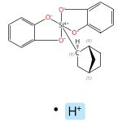  Relative stereochemistry shown |  | 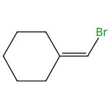 |  | 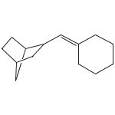

Engaging Alkenyl Halides with Alkylsilicates via Photoredox Dual Catalysis
By: Patel, Niki R.; et al
Organic Letters (2016), 18(4), 764-767.
Find It @ Emory
10.1021/acs.orglett.6b00024
View All Sources in CAS SciFinder

Steps: 1, Yield: 90%
CAS Reaction Number: 31-614-CAS-30603112
1.1 | Catalysts: Dichloro[1,2-di(methoxy-κO)ethane]nickel, Tris(2,2′-bipyridine)ruthenium(2+) bis(hexafluorophosphate), 4,4′-Bis(1,1-dimethylethyl)-2,2′-bipyridine; rt
1.2 | Solvents: Dimethylformamide; 24 h, 27 °C

13. Scheme 13 (1 Reaction)

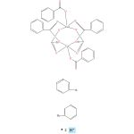 |  | 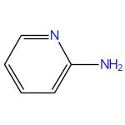 |  | 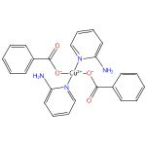

Copper(II) benzoates and acetates with 2-aminopyridine
By: Kozlevcar, Bojan; et al
Acta Chimica Slovenica (2001), 48(3), 363-374.
Find It @ Emory
View All Sources in CAS SciFinder

Steps: 1, Yield: 95%
CAS Reaction Number: 31-562-CAS-2982502
1.1 | Solvents: Acetonitrile

14. Scheme 14 (1 Reaction)

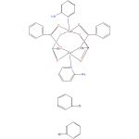

Copper(II) benzoates and acetates with 2-aminopyridine
By: Kozlevcar, Bojan; et al
Acta Chimica Slovenica (2001), 48(3), 363-374.
Find It @ Emory
View All Sources in CAS SciFinder

Steps: 1, Yield: 95%
CAS Reaction Number: 31-562-CAS-9390869
1.1 | Solvents: Acetonitrile

15. Scheme 15 (1 Reaction)

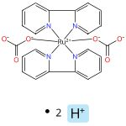 |  | 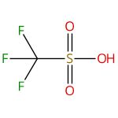 |  | 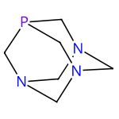
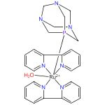
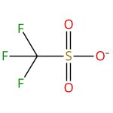

Ruthenium Complexes Containing 2,2’-Bipyridine and 1,3,5-Triaza-7-phosphaadamantane
By: Scalambra, Franco; et al
European Journal of Inorganic Chemistry (2016), 2016(10), 1528-1540.
Find It @ Emory
10.1002/ejic.201501357
View All Sources in CAS SciFinder

Steps: 1, Yield: 99%
CAS Reaction Number: 31-562-CAS-15746954
1.1 | Solvents: Water; 15 min, rt
1.2 | Solvents: Water; 15 min, rt; 30 min, rt

16. Scheme 16 (1 Reaction)

 |  | 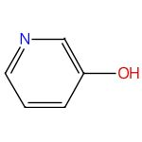 |  | 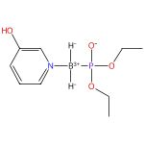

Reaction of Boranephosphonate Diesters with Pyridines or Tertiary Amines in the Presence of Iodine: Synthetic and Mechanistic Studies
By: Golebiewska, Justyna; et al
Journal of Organic Chemistry (2020), 85(6), 4312-4323.
Find It @ Emory
10.1021/acs.joc.9b03506
View All Sources in CAS SciFinder

Steps: 1, Yield: 94%
CAS Reaction Number: 31-614-CAS-28673290
1.1 | Reagents: Iodine
 | Solvents: Dichloromethane; 10 min, rt

17. Scheme 17 (1 Reaction)

Absolute stereochemistry shown,  Rotation (-)  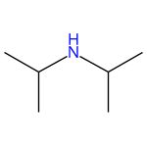 |  | 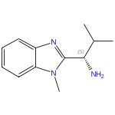  Absolute stereochemistry shown |  | 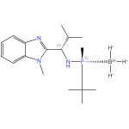  Absolute stereochemistry shown,  Rotation (-)

Iridium complexes with P-stereogenic phosphino imidazole ligands: Synthesis, structure and catalysis
By: Alvarez-Yebra, Ruben; et al
Tetrahedron (2019), 75(32), 4358-4364.
Find It @ Emory
10.1016/j.tet.2019.04.032
View All Sources in CAS SciFinder

Steps: 1, Yield: 96%
CAS Reaction Number: 31-614-CAS-24069217
1.1 | Reagents: Triethylamine, Methanesulfonic anhydride
 | Solvents: Dichloromethane; rt → -20 °C; 1.5 h, -20 °C
1.2 | Solvents: Dichloromethane; -20 °C
1.3 | Reagents: Water; -20 °C → rt

18. Scheme 18 (1 Reaction)

Absolute stereochemistry shown,  Rotation (-) |  | 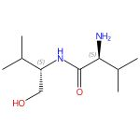  Absolute stereochemistry shown,  Rotation (-) |  | 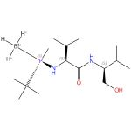  Absolute stereochemistry shown

Dialkylammonium tert-Butylmethylphosphinites: Stable Intermediates for the Synthesis of P-Stereogenic Ligands
By: Salomo, Ernest; et al
Journal of Organic Chemistry (2017), 82(13), 7065-7069.
Find It @ Emory
10.1021/acs.joc.7b01180
View All Sources in CAS SciFinder

Steps: 1, Yield: 93%
CAS Reaction Number: 31-614-CAS-28293475
1.1 | Reagents: Triethylamine, Methanesulfonic anhydride
 | Solvents: Dichloromethane; -20 °C; -20 °C; 1.5 h, -20 °C
1.2 | overnight, -20 °C
1.3 | Reagents: Sodium hydroxide
 | Solvents: Water

19. Scheme 19 (1 Reaction)

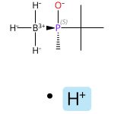  Absolute stereochemistry shown,  Rotation (+) |  | 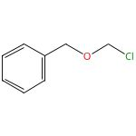 |  | 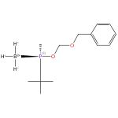  Absolute stereochemistry shown,  Rotation (-)

BOM-Phosphinite as an Electrophilic P-Stereogenic Transfer Reagent for the Synthesis of Bulky Phosphines: Synthesis of tert-Butyl(3,5-di-tert-butylphenyl)BisP*
By: Rojo, Pep; et al
Organic Letters (2021), 23(12), 4802-4806.
Find It @ Emory
10.1021/acs.orglett.1c01522
View All Sources in CAS SciFinder

Steps: 1, Yield: 90%
CAS Reaction Number: 31-614-CAS-30466996
1.1 | Reagents: Triethylamine
 | Solvents: Dichloromethane; 25 °C → 0 °C
1.2 | 0 °C; 0 °C → 25 °C; 2 h, 25 °C

20. Scheme 20 (1 Reaction)

Absolute stereochemistry shown,  Rotation (+) |  |  |  | 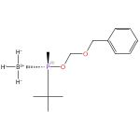  Absolute stereochemistry shown,  Rotation (+)

BOM-Phosphinite as an Electrophilic P-Stereogenic Transfer Reagent for the Synthesis of Bulky Phosphines: Synthesis of tert-Butyl(3,5-di-tert-butylphenyl)BisP*
By: Rojo, Pep; et al
Organic Letters (2021), 23(12), 4802-4806.
Find It @ Emory
10.1021/acs.orglett.1c01522
View All Sources in CAS SciFinder

Steps: 1, Yield: 90%
CAS Reaction Number: 31-614-CAS-25350502
1.1 | Reagents: Triethylamine
 | Solvents: Dichloromethane; 25 °C → 0 °C
1.2 | 0 °C; 0 °C → 25 °C; 2 h, 25 °C

21. Scheme 21 (1 Reaction)

Relative stereochemistry shown |  | 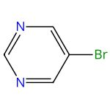 |  | 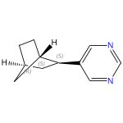  Relative stereochemistry shown

Base-Free Photoredox/Nickel Dual-Catalytic Cross-Coupling of Ammonium Alkylsilicates
By: Jouffroy, Matthieu; et al
Journal of the American Chemical Society (2016), 138(2), 475-478.
Find It @ Emory
10.1021/jacs.5b10963
View All Sources in CAS SciFinder

Steps: 1, Yield: 98%
CAS Reaction Number: 31-614-CAS-28810867
1.1 | Catalysts: Dichloro[1,2-di(methoxy-κO)ethane]nickel, 4,4′-Bis(1,1-dimethylethyl)-2,2′-bipyridine
 | Solvents: Tetrahydrofuran; heated; cooled
1.2 | Catalysts: Tris(2,2′-bipyridine)ruthenium(2+) bis(hexafluorophosphate)
 | Solvents: Dimethylformamide; 3 h, 30 °C

22. Scheme 22 (3 Reactions)

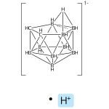  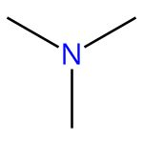 |  | 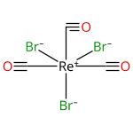  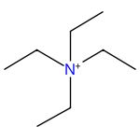 |  | 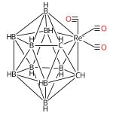

Preparation of rhenium and technetium carborane complexes as synthons for radiopharmaceuticals
Assignee: McMaster University
United States, US20030068271 A1 2003-04-10
Espacenet
View All Sources in CAS SciFinder

Steps: 1, Yield: 93%
CAS Reaction Number: 31-614-CAS-25272010
1.1 | Reagents: Ethanol, thallium(1+) salt (1:1)
 | Solvents: Tetrahydrofuran; 1 h, -20 °C → rt
1.2 | Solvents: Tetrahydrofuran; overnight, rt → reflux

Method for preparing technetium- and rhenium-carborane complexes for radioimaging and radiotherapy
Assignee: McMaster University
Canada, CA2348831 A1 2002-11-25
Espacenet
View All Sources in CAS SciFinder

Steps: 1, Yield: 93%
CAS Reaction Number: 31-614-CAS-27368230
1.1 | Reagents: Ethanol, thallium(1+) salt (1:1)
 | Solvents: Tetrahydrofuran; 1 h, -20 °C → rt
1.2 | Solvents: Tetrahydrofuran; overnight, reflux

Carboranes as Ligands for the Preparation of Organometallic Tc and Re Radiopharmaceuticals. Synthesis of [M(CO)3(η5-2,3-C2B9H11)]- and rac-[M(CO)3(η5-2-R-2,3-C2B9H10)]- (M = Re, 99Tc; R = CH2CH2CO2H) from [M(CO)3Br3]2-
By: Valliant, John F.; et al
Inorganic Chemistry (2002), 41(4), 628-630.
Find It @ Emory
10.1021/ic0156285
View All Sources in CAS SciFinder

Steps: 1, Yield: 93%
CAS Reaction Number: 31-614-CAS-30246387
1.1 | Reagents: Ethanol, thallium(1+) salt (1:1)
 | Solvents: Tetrahydrofuran
1.2 | Solvents: Tetrahydrofuran

23. Scheme 23 (1 Reaction)

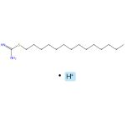 |  | 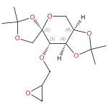  Absolute stereochemistry shown |  | 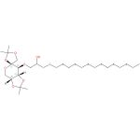  Absolute stereochemistry shown

Odorless regioselective ring opening of epoxides with S-alkylisothiouronium salts as masked thiols in water
By: Panchadhayee, Rajib; et al
ARKIVOC (Gainesville, FL, United States) (2008), (2), 298-307.
Find It @ Emory
10.3998/ark.5550190.0010.228
View All Sources in CAS SciFinder

Steps: 1, Yield: 92%
CAS Reaction Number: 31-614-CAS-30583977
1.1 | Reagents: Sodium hydroxide
 | Solvents: Water; 40 min, rt

24. Scheme 24 (1 Reaction)

 |  | 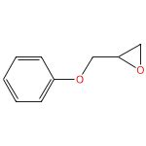 |  | 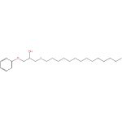

Odorless regioselective ring opening of epoxides with S-alkylisothiouronium salts as masked thiols in water
By: Panchadhayee, Rajib; et al
ARKIVOC (Gainesville, FL, United States) (2008), (2), 298-307.
Find It @ Emory
10.3998/ark.5550190.0010.228
View All Sources in CAS SciFinder

Steps: 1, Yield: 90%
CAS Reaction Number: 31-614-CAS-25636170
1.1 | Reagents: Sodium hydroxide
 | Solvents: Water; 45 min, rt

25. Scheme 25 (1 Reaction)

 |  | 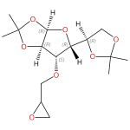  Absolute stereochemistry shown |  | 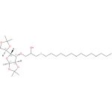  Absolute stereochemistry shown

Odorless regioselective ring opening of epoxides with S-alkylisothiouronium salts as masked thiols in water
By: Panchadhayee, Rajib; et al
ARKIVOC (Gainesville, FL, United States) (2008), (2), 298-307.
Find It @ Emory
10.3998/ark.5550190.0010.228
View All Sources in CAS SciFinder

Steps: 1, Yield: 90%
CAS Reaction Number: 31-614-CAS-25654851
1.1 | Reagents: Sodium hydroxide
 | Solvents: Water; 45 min, rt

26. Scheme 26 (1 Reaction)

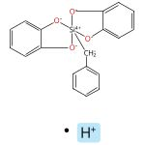 |  | 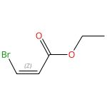  Double bond geometry shown |  | 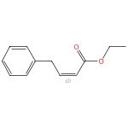  Double bond geometry shown

Engaging Alkenyl Halides with Alkylsilicates via Photoredox Dual Catalysis
By: Patel, Niki R.; et al
Organic Letters (2016), 18(4), 764-767.
Find It @ Emory
10.1021/acs.orglett.6b00024
View All Sources in CAS SciFinder

Steps: 1, Yield: 90%
CAS Reaction Number: 31-614-CAS-29700679
1.1 | Catalysts: Dichloro[1,2-di(methoxy-κO)ethane]nickel, Tris(2,2′-bipyridine)ruthenium(2+) bis(hexafluorophosphate), 4,4′-Bis(1,1-dimethylethyl)-2,2′-bipyridine; rt
1.2 | Solvents: Dimethylformamide; 24 h, 27 °C

27. Scheme 27 (1 Reaction)

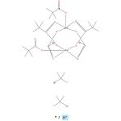 |  | 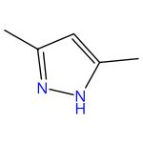 |  | 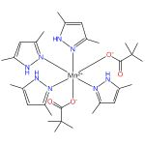

Manganese(II) carboxylates containing coordinated 3,5-dimethylpyrazole
By: Uvarova, M. A.; et al
Russian Journal of Inorganic Chemistry (2015), 60(8), 934-941.
Find It @ Emory
10.1134/s0036023615080215
View All Sources in CAS SciFinder

Steps: 1, Yield: 91%
CAS Reaction Number: 31-562-CAS-16739735
1.1 | Solvents: Dichloromethane; 1 h, rt

28. Scheme 28 (1 Reaction)

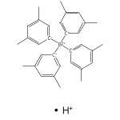 |  | 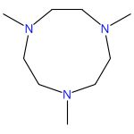 |  | 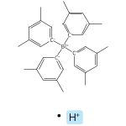

A tetranuclear calcium hydride cluster with a highly symmetric [Ca4H6]2+ core
By: Schuhknecht, Danny; et al
Chemical Communications (Cambridge, United Kingdom) (2019), 55(98), 14837-14839.
Find It @ Emory
10.1039/c9cc08540h
View All Sources in CAS SciFinder

Steps: 1, Yield: 97%
CAS Reaction Number: 31-575-CAS-20993243
1.1 | Solvents: Diethyl ether; rt; 1 h, rt

29. Scheme 29 (1 Reaction)

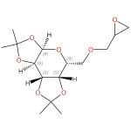  Absolute stereochemistry shown |  | 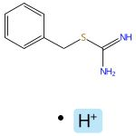 |  | 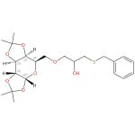  Absolute stereochemistry shown

Odorless regioselective ring opening of epoxides with S-alkylisothiouronium salts as masked thiols in water
By: Panchadhayee, Rajib; et al
ARKIVOC (Gainesville, FL, United States) (2008), (2), 298-307.
Find It @ Emory
10.3998/ark.5550190.0010.228
View All Sources in CAS SciFinder

Steps: 1, Yield: 95%
CAS Reaction Number: 31-614-CAS-28881466
1.1 | Reagents: Sodium hydroxide
 | Solvents: Water; 30 min, rt

30. Scheme 30 (1 Reaction)

 |  | 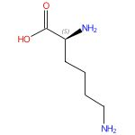  Absolute stereochemistry shown |  | Absolute stereochemistry shown

Synthesis and some transformations of di(o-carborano-1,2-dimethyl)borate
By: Kazantsev, A. V.; et al
Russian Journal of General Chemistry (2016), 86(1), 199-201.
Find It @ Emory
10.1134/s1070363216010333
View All Sources in CAS SciFinder

Steps: 1, Yield: 93%
CAS Reaction Number: 31-614-CAS-29895087
1.1 | Solvents: Ethanol, Water; 20 °C; 4 h, 50 - 60 °C

31. Scheme 31 (1 Reaction)

 |  | Absolute stereochemistry shown |  | 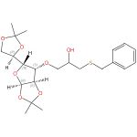  Absolute stereochemistry shown

Odorless regioselective ring opening of epoxides with S-alkylisothiouronium salts as masked thiols in water
By: Panchadhayee, Rajib; et al
ARKIVOC (Gainesville, FL, United States) (2008), (2), 298-307.
Find It @ Emory
10.3998/ark.5550190.0010.228
View All Sources in CAS SciFinder

Steps: 1, Yield: 92%
CAS Reaction Number: 31-614-CAS-30726178
1.1 | Reagents: Sodium hydroxide
 | Solvents: Water; 30 min, rt

32. Scheme 32 (1 Reaction)

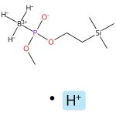 |  | 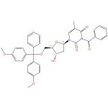  Absolute stereochemistry shown,  Rotation (+) |  | 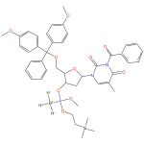

A Novel Method for the Synthesis of Dinucleoside Boranophosphates by a Borano-Phospho-Triester Method
By: Shimizu, Mamoru; et al
Journal of Organic Chemistry (2004), 69(16), 5261-5268.
Find It @ Emory
10.1021/jo0493875
View All Sources in CAS SciFinder

Steps: 1, Yield: 91%
CAS Reaction Number: 31-614-CAS-27672022
1.1 | Reagents: Diisopropylethylamine, 3-Nitro-1,2,4-triazole, Bis(2-oxo-3-oxazolidinyl)phosphinic chloride
 | Solvents: Tetrahydrofuran; 30 min, rt

33. Scheme 33 (1 Reaction)

 |  | 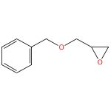 |  | 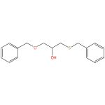

Odorless regioselective ring opening of epoxides with S-alkylisothiouronium salts as masked thiols in water
By: Panchadhayee, Rajib; et al
ARKIVOC (Gainesville, FL, United States) (2008), (2), 298-307.
Find It @ Emory
10.3998/ark.5550190.0010.228
View All Sources in CAS SciFinder

Steps: 1, Yield: 90%
CAS Reaction Number: 31-614-CAS-29662986
1.1 | Reagents: Sodium hydroxide
 | Solvents: Water; 30 min, rt

34. Scheme 34 (1 Reaction)

 |  | 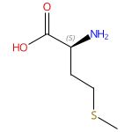  Absolute stereochemistry shown |  | Absolute stereochemistry shown

Synthesis and some transformations of di(o-carborano-1,2-dimethyl)borate
By: Kazantsev, A. V.; et al
Russian Journal of General Chemistry (2016), 86(1), 199-201.
Find It @ Emory
10.1134/s1070363216010333
View All Sources in CAS SciFinder

Steps: 1, Yield: 96%
CAS Reaction Number: 31-614-CAS-25069454
1.1 | Solvents: Ethanol, Water; 20 °C; 4 h, 50 - 60 °C

35. Scheme 35 (1 Reaction)

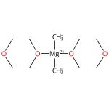 |  | 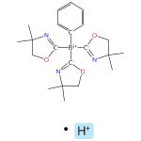 |  | 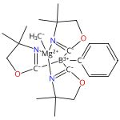

Concerted C-N and C-H Bond Formation in a Magnesium-Catalyzed Hydroamination
By: Dunne, James F.; et al
Journal of the American Chemical Society (2010), 132(50), 17680-17683.
Find It @ Emory
10.1021/ja108881s
View All Sources in CAS SciFinder

Steps: 1, Yield: 95%
CAS Reaction Number: 31-562-CAS-9893089
1.1 | Solvents: Benzene; 30 min, rt

36. Scheme 36 (1 Reaction)

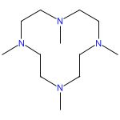

Regioselective Hydrosilylation of Olefins Catalyzed by a Molecular Calcium Hydride Cation
By: Schuhknecht, Danny; et al
Angewandte Chemie, International Edition (2020), 59(1), 310-314.
Find It @ Emory
10.1002/anie.201909585
View All Sources in CAS SciFinder

Steps: 1, Yield: 98%
CAS Reaction Number: 31-575-CAS-20888016
1.1 | Solvents: Diethyl ether; rt; 1 h, rt

37. Scheme 37 (1 Reaction)

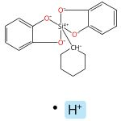 |  | 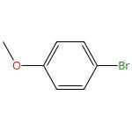 |  | 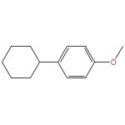

Base-Free Photoredox/Nickel Dual-Catalytic Cross-Coupling of Ammonium Alkylsilicates
By: Jouffroy, Matthieu; et al
Journal of the American Chemical Society (2016), 138(2), 475-478.
Find It @ Emory
10.1021/jacs.5b10963
View All Sources in CAS SciFinder

Steps: 1, Yield: 94%
CAS Reaction Number: 31-614-CAS-26444394
1.1 | Catalysts: Dichloro[1,2-di(methoxy-κO)ethane]nickel, 4,4′-Bis(1,1-dimethylethyl)-2,2′-bipyridine
 | Solvents: Tetrahydrofuran; heated; cooled
1.2 | Catalysts: Tris(2,2′-bipyridine)ruthenium(2+) bis(hexafluorophosphate)
 | Solvents: Dimethylformamide; 16 h, 30 °C

38. Scheme 38 (1 Reaction)

Relative stereochemistry shown |  |  |  | 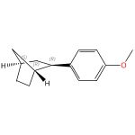  Relative stereochemistry shown

Base-Free Photoredox/Nickel Dual-Catalytic Cross-Coupling of Ammonium Alkylsilicates
By: Jouffroy, Matthieu; et al
Journal of the American Chemical Society (2016), 138(2), 475-478.
Find It @ Emory
10.1021/jacs.5b10963
View All Sources in CAS SciFinder

Steps: 1, Yield: 91%
CAS Reaction Number: 31-614-CAS-27233862
1.1 | Catalysts: Dichloro[1,2-di(methoxy-κO)ethane]nickel, 4,4′-Bis(1,1-dimethylethyl)-2,2′-bipyridine
 | Solvents: Tetrahydrofuran; heated; cooled
1.2 | Catalysts: Tris(2,2′-bipyridine)ruthenium(2+) bis(hexafluorophosphate)
 | Solvents: Dimethylformamide; 16 h, 30 °C

39. Scheme 39 (1 Reaction)

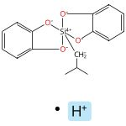 |  | 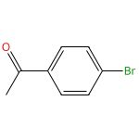 |  | 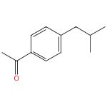

Thioetherification via Photoredox/Nickel Dual Catalysis
By: Jouffroy, Matthieu; et al
Organic Letters (2016), 18(4), 876-879.
Find It @ Emory
10.1021/acs.orglett.6b00208
View All Sources in CAS SciFinder

Steps: 1, Yield: 100%
CAS Reaction Number: 31-614-CAS-27190422
1.1 | Catalysts: Dichloro[1,2-di(methoxy-κO)ethane]nickel, Tris(2,2′-bipyridine)ruthenium(2+) bis(hexafluorophosphate), 4,4′-Bis(1,1-dimethylethyl)-2,2′-bipyridine
 | Solvents: Dimethylformamide; 24 h, 27 °C

40. Scheme 40 (1 Reaction)

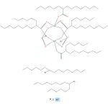 |  | 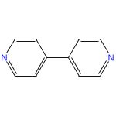 |  | 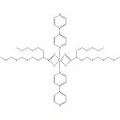  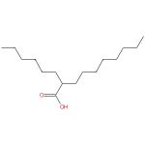

Structural, mesomorphic, photoluminescence and thermoelectric studies of mononuclear and polymeric complexes of copper(II) with 2-hexyldecanoato and 4,4’-bipyridine ligands
By: Abdullah, Norbani; et al
Journal of Materials Chemistry C: Materials for Optical and Electronic Devices (2015), 3(42), 11036-11045.
Find It @ Emory
10.1039/c5tc02273h
View All Sources in CAS SciFinder

Steps: 1, Yield: 96%
CAS Reaction Number: 31-614-CAS-29276342
1.1 | Solvents: Ethanol; heated

41. Scheme 41 (1 Reaction)

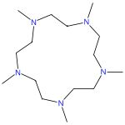

Calcium Hydride Catalysts for Olefin Hydrofunctionalization: Ring-Size Effect of Macrocyclic Ligands on Activity
By: Hoellerhage, Thomas; et al
Chemistry - A European Journal (2021), 27(9), 3002-3007.
Find It @ Emory
10.1002/chem.202004931
View All Sources in CAS SciFinder

Steps: 1, Yield: 95%
CAS Reaction Number: 31-614-CAS-31604808
1.1 | Solvents: Diethyl ether; rt; 1 h, rt

42. Scheme 42 (1 Reaction)

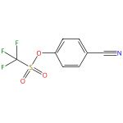 |  | 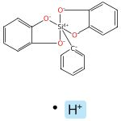 |  | 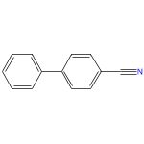

Preparation and Palladium-Catalyzed Cross-Coupling of Aryl Triethylammonium Bis(catechol) Silicates with Aryl Triflates
By: Seganish, W. Michael; et al
Journal of Organic Chemistry (2004), 69(4), 1137-1143.
Find It @ Emory
10.1021/jo035309q
View All Sources in CAS SciFinder

Steps: 1, Yield: 91%
CAS Reaction Number: 31-177-CAS-11766675
1.1 | Reagents: Tetrabutylammonium fluoride
 | Catalysts: Bis(dibenzylideneacetone)palladium, 2-(Dicyclohexylphosphino)biphenyl
 | Solvents: Tetrahydrofuran; 6 h, reflux

43. Scheme 43 (1 Reaction)

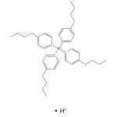 |  |  |  | 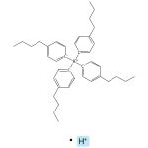

Calcium Hydride Catalysts for Olefin Hydrofunctionalization: Ring-Size Effect of Macrocyclic Ligands on Activity
By: Hoellerhage, Thomas; et al
Chemistry - A European Journal (2021), 27(9), 3002-3007.
Find It @ Emory
10.1002/chem.202004931
View All Sources in CAS SciFinder

Steps: 1, Yield: 90%
CAS Reaction Number: 31-614-CAS-31604815
1.1 | Solvents: Benzene; 5 min, rt

44. Scheme 44 (1 Reaction)

 |  | 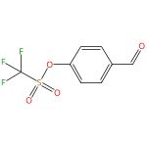 |  | 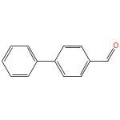

Preparation and Palladium-Catalyzed Cross-Coupling of Aryl Triethylammonium Bis(catechol) Silicates with Aryl Triflates
By: Seganish, W. Michael; et al
Journal of Organic Chemistry (2004), 69(4), 1137-1143.
Find It @ Emory
10.1021/jo035309q
View All Sources in CAS SciFinder

Steps: 1, Yield: 98%
CAS Reaction Number: 31-177-CAS-12378198
1.1 | Reagents: Tetrabutylammonium fluoride
 | Catalysts: Bis(dibenzylideneacetone)palladium, 2-(Dicyclohexylphosphino)biphenyl
 | Solvents: Tetrahydrofuran; 6 h, reflux

45. Scheme 45 (1 Reaction)

 |  | 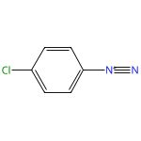  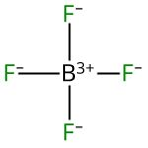 |  | 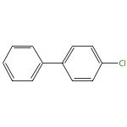

New transmetalation reagents for the gold-catalyzed visible light-enabled C(sp or sp2)-C(sp2) cross-coupling with aryldiazonium salts in the absence of a photosensitizer
By: Witzel, Sina; et al
Chemical Communications (Cambridge, United Kingdom) (2018), 54(98), 13802-13804.
Find It @ Emory
10.1039/c8cc08227h
View All Sources in CAS SciFinder

Steps: 1, Yield: 92%
CAS Reaction Number: 31-614-CAS-29397439
1.1 | Catalysts: Chloro[tris[4-(trifluoromethyl)phenyl]phosphine-κP]gold
 | Solvents: Methanol; 15 - 17 h, rt

Copyright © 2025 American Chemical Society (ACS). All Rights Reserved.

